Quarterly Report – Public Page

Date of Report: 7th Quarterly Report-June 28, 2024
Contract Number: 693JK32210002POTA
Prepared for: Government Agency: DOT and Co-funders
Project Title: Monitoring the Long-Term Compatibility of Vapor Corrosion Inhibitor and Cathodic Protection Associated Components
Prepared by: Pipeline Research Council International, Inc.
Contact Information: Dorothy Lam, email: dlam@prci.org
For quarterly period ending: June 30, 2024

1: Items Completed During this Quarterly Period:

Item # | Task # | Activity/Deliverable | Title | Federal Cost | Cost Share
24 | 2 | Monitor progress of the various field testing | Summary of the progress to be included in quarterly report | $3,258 | $3,258
25 | 3 | Continue collecting various CP survey data for the VCI-treated tanks | Summary of the data to be included in the quarterly report | $3,258 | $3,258
26 | 5 | Quarterly status report & project management | Submit 7th quarterly report | $13,603 | $13,603

2: Items Not Completed During this Quarterly Period:

Item # | Task # | Activity/Deliverable | Title | Federal Cost | Cost Share
20 | 4 | Inject VCIs in the laboratory and large-scale experiments | Summary to be included in quarterly report | $3,258 | $3,258

3: Project Financial Tracking During this Quarterly Period:

Note that this chart reflects Federal share only.

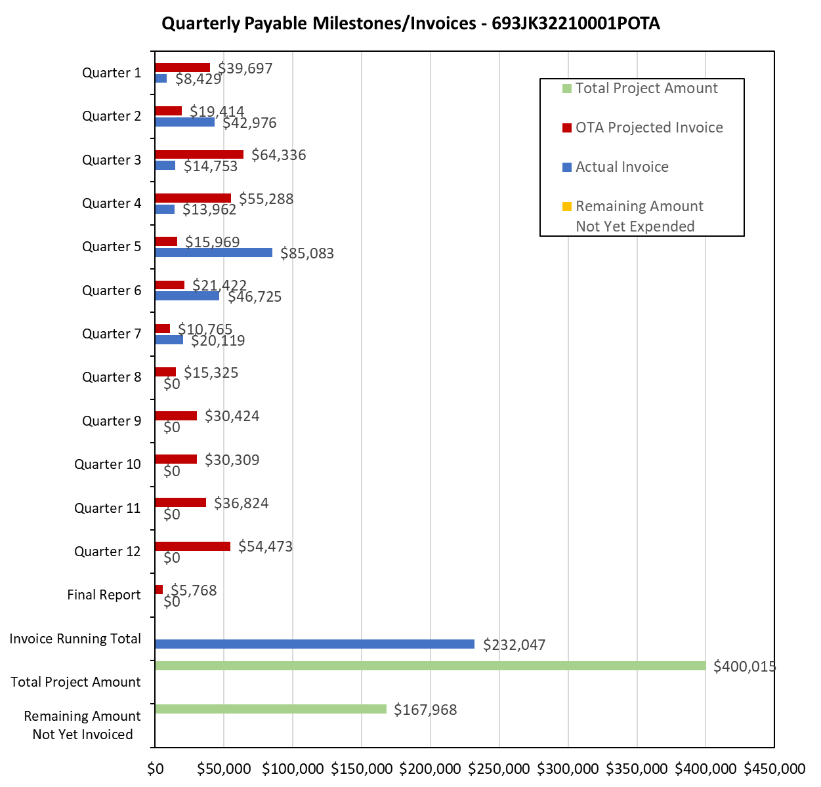

4: Project Technical Status:

Item 24, Task 2 ⎯ Monitor progress of the various field testing. Summary of the progress to be included in quarterly report: The field testing for the VCI-treated tanks and recently-VCI-treated tanks was started in the 5th quarter. The monitoring data for two quarters have been collected for those tanks. The field sand samples from the previously treated VCI tanks have been received and analyzed. The field sand samples from the recently-treated-with-VCI tanks have also been received and are being analyzed. The coupons that were placed under some of the VCI treated tanks will be removed during the first month of the next quarter. This activity links to items 6 and 7 as listed in Attachment 1 Team Project Activities. This activity also satisfies item 16 in Attachment 2 Project Deliverables.

Item 25, Task 3 ⎯ Continue collecting various CP survey data for the VCI-treated tanks. Summary of the data to be included in the quarterly report: The CP survey data for twenty additional VCI treated tanks, i.e., tanks besides those in the 6th quarterly report, became available in this quarter. The data span for these 20 tanks is 4 years. For several tanks, no data is available before VCI application. An analysis of the tanks, where both post- and pre-VCI treatment data is available, shows no specific trends in the rectifier current output or ground bed resistance. This observation is consistent with the data presented in the sixth quarterly report. The project team plans to make an additional data request to the tank operators for these additional 20 tanks and include it in the final report. This activity links to item 8 as listed in Attachment 1 Team Project Activities. This activity also satisfies item 16 in Attachment 2 Project Deliverables.

Item 26, Task 5 ⎯ Quarterly status report & project management. Submit 7th quarterly report: The 7th quarter project meeting was held.. This item has been completed, and it partly satisfies item 25 in Attachment 2 Project Deliverables. It also links to item 13 as listed in Attachment 1 Team Project Activities. The meeting minutes in the appendix link to item 11 as listed in Attachment 1 Team Project Activities.

5: Project Schedule:

Item 20, Task 4 ⎯ Inject VCIs in the laboratory and large-scale experiments. Summary to be included in quarterly report: The revised design of the laboratory experiments over VCI migration in the clay-like pads include VCI delivery at the start of the experiments. The VCI injections in the laboratory experiments have been completed. Regarding the two large-scale experiments, VCI injection schedule is determined based on ER probe data. One of the VCIs was injected in the first large-scale experiment. However, it was decided to not inject VCI in the second large-scale experiment because ER probe data analysis and CP conditions were not met for the injection; the VCI injection has been postponed by two months, and it will be undertaken during the middle of next quarter.

Overall, the project is a bit behind schedule, but activities will catch up in the next quarter.

